Assignment -4

|  |  |
| --- | --- |
| Assignment Date | 20 OCTOBER 2022 |
| Student Name | Saranya J |
| Student Roll Number | 722819106089 |
| Maximum Marks | 2 Marks |

**Question-1:**

Write code and connections in wowki for ultrasonic sensor.

Whenever distance is less than 100 cms send “alert” to IBM cloud and display in

device recent events.

|  |
| --- |
| **Solution:** |
| **WOWKI LINK:** <https://wokwi.com/projects/346235465961046612> |

#include <WiFi.h> #include <PubSubClient.h> #define TRIGGER 2

#define ECHO 15

#define sound_speed 0.034 int distance;

void callback(char* subscribetopic, byte* payload, unsigned int payloadLength);

//-------credentials of IBM Accounts------

#define ORG "wp72r7"

#define DEVICE_TYPE "iot-device-1" #define DEVICE_ID "123456789"

#define TOKEN "987654321"

String data3;

//-------- Customise the above values --------

char server[] = ORG ".messaging.internetofthings.ibmcloud.com"; char publishTopic[] = "iot-2/evt/Data/fmt/json";

char subscribetopic[] = "iot-2/cmd/test/fmt/String"; char authMethod[] = "use-token-auth";

char token[] = TOKEN;

//-----------------------------------------

WiFiClient wifiClient;

PubSubClient client(server, 1883, callback ,wifiClient); void setup()

{

Serial.begin(115200); pinMode(TRIGGER, OUTPUT); pinMode(ECHO, INPUT); delay(10);

Serial.println(); wificonnect(); mqttconnect();

}

void loop()

{

digitalWrite(TRIGGER, HIGH); delayMicroseconds(10); digitalWrite(TRIGGER, LOW);

int duration=pulseIn(ECHO,HIGH); distance=(duration*sound_speed)/2; Serial.print("Distance:"); Serial.print(distance); Serial.println("cms"); if(distance<100){ PublishData(distance);

}

delay(1000);

if (!client.loop()) { mqttconnect();

}

}

void PublishData(int d) { mqttconnect();

String payload = "{\"message\":alert}";

Serial.print("Sending payload: "); Serial.println(payload);

if (client.publish(publishTopic, (char*) payload.c_str())) { Serial.println("Publish ok");

} else {

Serial.println("Publish failed");

}

}

void mqttconnect() {

if (!client.connected()) { Serial.print("Reconnecting client to "); Serial.println(server);

while (!!!client.connect(clientId, authMethod, token)) { Serial.print(".");

delay(500);

}

initManagedDevice(); Serial.println();

}

}

void wificonnect()

{

Serial.println(); Serial.print("Connecting to ");

WiFi.begin("Wokwi-GUEST", "", 6);

while (WiFi.status() != WL_CONNECTED) { delay(500);

Serial.print(".");

Serial.println(""); Serial.println("WiFi connected"); Serial.println("IP address: "); Serial.println(WiFi.localIP());

}

void initManagedDevice() {

if (client.subscribe(subscribetopic)) { Serial.println((subscribetopic)); Serial.println("subscribe to cmd OK");

} else {

Serial.println("subscribe to cmd FAILED");

}

}

void callback(char* subscribetopic, byte* payload, unsigned int payloadLength)

{

Serial.print("callback invoked for topic: "); Serial.println(subscribetopic);

for (int i = 0; i < payloadLength; i++) { data3 += (char)payload[i];

}

Serial.println("data: "+ data3); data3="";

}

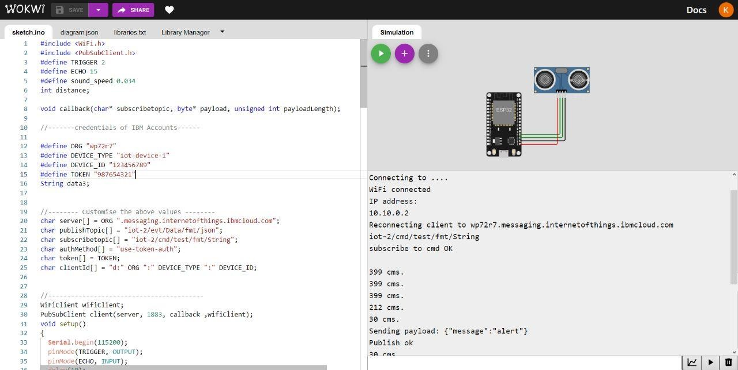

IBM CLOUD RECENT EVENTS:

